Bottega Restaurant

1132 Valencia St San Francisco, CA 94158

Website: https://www.bottegavalencia.com/





RESTAURANT

REVIEW ANALYSIS

By Aishwarya Kande

Data Analytics Intern at CodEvo Solutions

Id: xl7uklin

Date: 28/08/2024

CONTENTS

|  |  |  |
| --- | --- | --- |
| S. No | Content | Page no. |
| 1.  2.  3.  4.  5.  6.  7.  8. | About this Report  Methodology  Analytical Tools and Techniques  Visualization and Findings  Key Findings and Insights  Recommendations  Conclusion  Appendices | 3  4  5  6-7  8  9  10  11 |

ABOUT THIS REPORT

This report looks at the “Restaurant Review Analysis” of Bottega Restaurant, using data collected from Yelp, a well-known site for customer reviews. The goal of this analysis is to find important insights about customer feelings, preferences, and areas that need improvement. This will help the restaurant’s management make better decisions.

First, we gathered a lot of customer reviews from Yelp. These reviews were then carefully organized and cleaned using Microsoft Excel to make sure the data was accurate and ready for analysis. Next, we used different methods to analyse the data, making it easier to understand customer opinions and experiences.

To show the findings clearly, we used Excel to create dashboards and charts. These visual tools highlight important patterns and trends in the customer feedback and make it easy for stakeholders to understand the data.

This report covers the entire process—from collecting and cleaning the data to analysing and visualizing it. It aims to give the restaurant’s management a clear understanding of their customers and support data-driven decisions to improve customer satisfaction and grow the business.

METHODOLOGY

Selection of Reviews:

* Time Frame: Reviews span different periods, capturing both recent and historical feedback from year 2024.
* Diversity: Includes 1-5 star ratings for balanced insights.

Data Collection:

* Data Points: Collected review text, ratings, dates manually.

Data Cleaning:

* Validation: Ensured consistency in key data fields.
* Handling Missing Data: Critical gaps were removed; non-critical gaps were imputed.
* Duplicate Removal: Identified and eliminated duplicates.

Text Preprocessing:

* Standardization: Cleaned and normalized text for analysis.

Data Structuring: Organized data into categories by rating, sentiment then imported into Excel for analysis.

Analytical Tools and Techniques

Data Collection:

* The data was collected from Yelp reviews, including key fields such as ratings, sentiments (positive, neutral, negative), number of photos, review comments, and date of review.
* Excel was used to clean, organize, and visualize the data.

Analysis Techniques:

* Pivot Tables: Used to analyze customer sentiments, ratings, and the relationship between the number of photos and ratings.
* Visualizations: Created using Excel's chart tools, including pie charts, bar charts, and line graphs to depict trends in sentiment and ratings.

* Sentiment Analysis: A simple classification system was used, categorizing reviews based on positive, neutral, and negative sentiments.

Visualization and Findings

1.Count of Sentiments (Pie Chart):

* Positive (40%): Majority of the reviews are positive, reflecting overall customer satisfaction.
* Negative (35%): A significant portion of reviews are negative, indicating areas for improvement.
* Neutral (25%): A quarter of the reviews express mixed or neutral feelings, suggesting room for enhancement in certain areas.

2.Avg Ratings vs No. of Photos (Scatter Plot):

* There's a positive correlation between the number of photos included in reviews and the average ratings. Reviews with more photos tend to have higher ratings.
* Reviews with no photos have an average rating of 2.7, while those with 4 or more photos consistently show a rating of 4.

3.Avg Ratings vs Sentiments (Bar Chart):

* Positive reviews have an average rating of 4.5.
* Neutral reviews average around 3.2.
* Negative reviews have a low average of 1.6, highlighting a stark difference between satisfied and dissatisfied customers.

4.Count of Sentiments vs Ratings (Horizontal Bar Chart):

* There’s a consistent distribution of sentiment counts across various rating levels, with the highest number of reviews coming in at the 5-star rating.

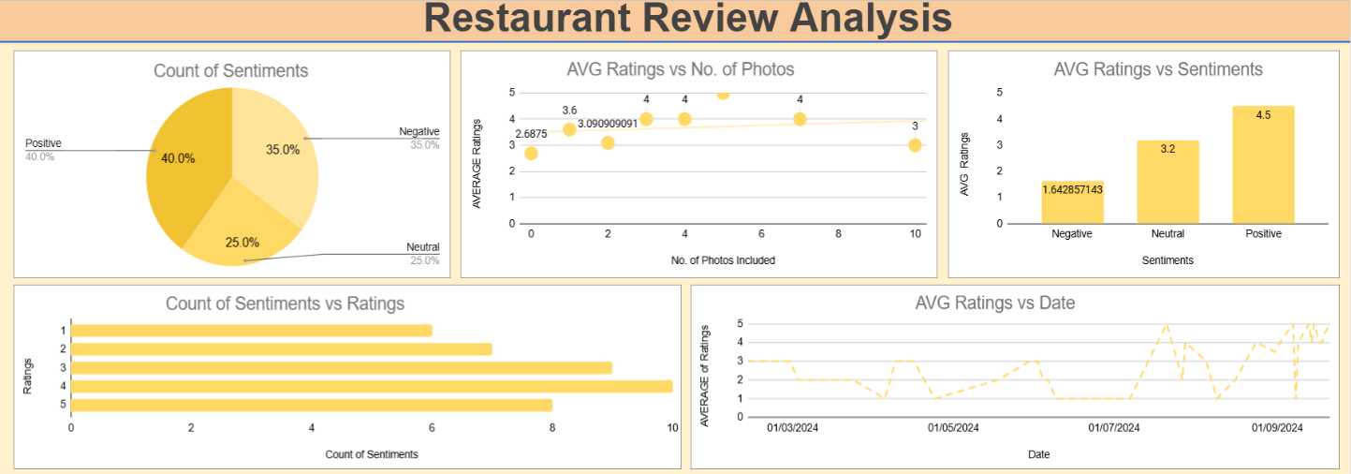

5.Avg Ratings vs Date (Line Chart):

* The average rating fluctuates over time, with noticeable dips and rises, indicating changing customer satisfaction over specific periods.

Key Findings and Insights

• Photo-Rating Correlation:

* Reviews with photos tend to have higher ratings, suggesting that customers who are more engaged (e.g., uploading photos) are generally more satisfied with their dining experience.

• Sentiment and Rating Alignment:

* As expected, there’s a clear alignment between customer sentiment and rating. Negative sentiments are strongly associated with lower ratings, while positive sentiments align with high ratings.

• Fluctuations in Ratings Over Time:

* Customer sentiment seems to fluctuate throughout the timeline, with peaks potentially corresponding to events, promotions, or holidays.

Recommendations

• Encourage Photo Uploads:

* Restaurants could encourage customers to upload more photos as reviews with more photos tend to have higher ratings. This can be done by offering small incentives such as discounts or free items.

• Target Negative Feedback:

* With 35% of reviews being negative, it’s essential for restaurants to focus on identifying recurring issues (e.g., service, food quality) and addressing them promptly. Customer service training and process improvements should be prioritized.

• Engage with Neutral Feedback:

* Neutral reviews, making up 25%, represent an opportunity for restaurants to convert these to positive sentiments. Following up with neutral reviewers for feedback and offering incentives for their next visit could help.

• Monitor Trends Over Time:

* The fluctuation in ratings over time highlights the need for regular monitoring of reviews. This will help restaurants act quickly on potential issues and leverage positive feedback during peak times (e.g., holidays).

Conclusion

* The analysis of Yelp reviews provides a clear picture of customer sentiment and the factors influencing restaurant ratings. While the overall sentiment is positive, there is a significant portion of negative reviews that must be addressed.
* Encouraging customer engagement through photo uploads and addressing common complaints can help improve the overall customer experience and online reputation.
* Quality Food & Ambiance: Consistently praised by customers, driving positive experiences and repeat visits.
* Attentive Staff: Noted for friendly, personalized service, enhancing overall satisfaction.
* Service Efficiency: Address wait times and service speed, especially during peak hours.
* Menu Variety & Pricing: Expand options and reassess pricing to attract a broader audience.
* Consistency: Strengthen quality control to maintain consistent food and service standards.

APPENDICES

A: Data Collection

Yelp Data Extraction: Includes reviews with columns like date, reviewer name, rating, sentiment, and comments.

Sample Data: Example review highlighting data points such as rating, sentiment, and specific comments.

B: Data Cleaning & Preparation

Cleaning Process: Removed duplicates, handled missing values, standardized formats, categorized sentiments.

Preparation Steps: Normalized text, transformed categorical data, integrated data sources.

C: Analytical Tools & Techniques

Tools Used: Excel for cleaning, Excel for dashboards.

Techniques: Sentiment and thematic analysis, trend analysis.

D: Visualization Examples

Excel Dashboards: Screenshots of key metrics and visualizations (e.g., ratings, sentiment, popular meals).

Charts: Rating distribution, sentiment counts per ratings.

Sample Figures: Average ratings, sentiment by rating.

E: Customer Feedback